USB RetroPad Adapter v1.1b for XBOX
User Manual Rev. 1.0 – 06/17/2012

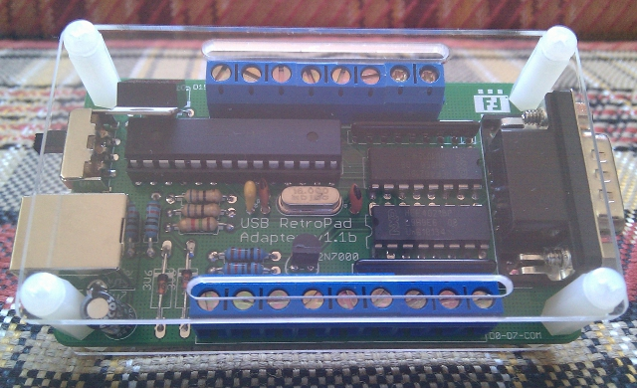
About the USB RetroPad Adapter
USB RetroPad Adapter is an USB joystick adapter that allows you to use the following classic controllers with your PC, Mac and PS3 through the USB port or with your classic XBOX console using an XBOX controller port to USB adapter, with the newly released USB RetroPad Adapter for XBOX:
:. Sega Genesis pad (also supports: Sega Master System, Atari 2600 and others)
:. Nintendo NES pad
:. Super NES pad
:. Playstation digital pads and Playstation 2 pads
:. Game Cube pad
:. Nintendo 64 pad
USB RetroPad Adapter also comes with handy screw terminal connectors (not available in the Lite Edition), allowing you to hook up a homemade arcade control to it and use it to play your favorite games on your PC, PS3 or XBOX!
How to use it
Arcade Mode (not available in the “Lite Edition”):
:. Slide the switch to the “Arcade” position if you want to use the adapter with the screw terminals attached to arcade stick and buttons
:. Each button/stick direction has two wires. Connect one of them to the COMM connector and the other one to any available screw (D0 – D15). Please refer to the reference table showing the screws/joystick button mappings.
Joystick Mode (DB9):
:. Slide the switch to the “DB9” position if you want to use the adapter with your classic controllers.
:. The adapter has native support for Sega Genesis, Master System and Atari 2600 controllers. If you are going to use one of these, just plug them to the DB9 port in the adapter, or;
:. If you are going to use any other joystick, you have to attach the joystick to the appropriate extension cable (sold/built separately), then plug the extension cable into the adapter.
:. Finally, just plug the adapter to your XBOX using an USB printer cable and an XBOX controller port to USB adapter (sold separately).
Button mapping table
XBOX | PS2 | Genesis | Arcade | NES | SNES | GC | N64
D-UP | D-UP | D-UP | D8 | D-UP | D-UP | D-UP | D-UP
D-DOWN | D-DOWN | D-DOWN | D9 | D-DOWN | D-DOWN | D-DOWN | D-DOWN
D-LEFT | D-LEFT | D-LEFT | D10 | D-LEFT | D-LEFT | D-LEFT | D-LEFT
D-RIGHT | D-RIGHT | D-RIGHT | D11 | D-RIGHT | D-RIGHT | D-RIGHT | D-RIGHT
Analog L | Analog L | - | - | - | - | Analog L | Analog Stick
Analog R | Analog R | - | - | - | - | Analog R | C Buttons
X | SQUARE | X | D12 | - | Y | Y | B
A | CROSS | A | D13 | A | B | B | A
B | CIRCLE | B | D15 | B | A | A | -
Y | TRIANGLE | Y | D14 | - | X | X | -
White | L1 | Z | D0 | - | L | - | -
L | L2 | - | D1 | - | - | L | L
Black | R1 | C | D2 | - | R | Z | Z
R | R2 | - | D3 | - | - | R | R
Back | SELECT | MODE | D4 | SELECT | SELECT | - | -
Start | START | START | D5 | START | START | START | START
L3 | L3 | - | D6 | - | - | - | -
R3 | R3 | D-UP + START | D7 | SELECT + START | SELECT + START | D-UP + START | D-UP + START

Additional Information
For more information about the USB RetroPad Adapter, please visit http://www.brunofreitas.com/

